National University of Computer & Emerging Sciences, Karachi
Spring -2025 CS-Department
Assignment- 2
18th March, 2025
Course Code: EE1005 | Course Name: Digital Logic Design (DLD)
Instructor Name: Muhammad Rahim
Date of Submission | 23rd March, 2025

- Write the Boolean expressions for the following logic circuits and simplify these expressions using Boolean algebra.

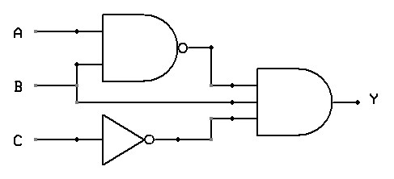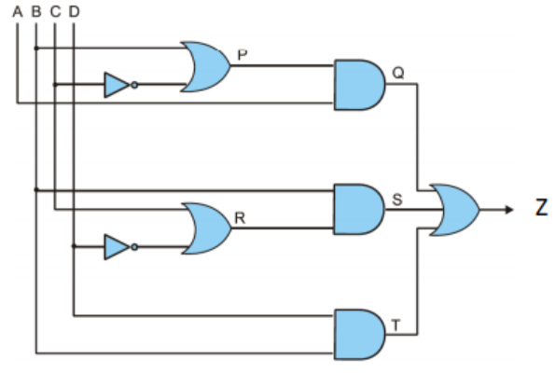
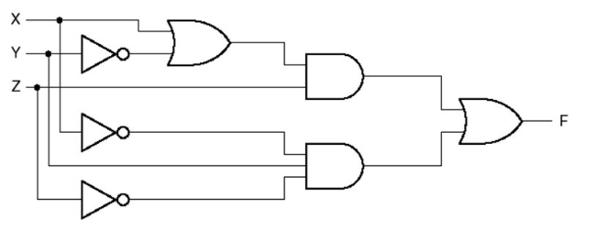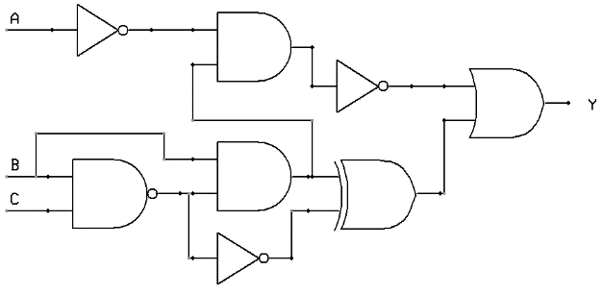
- Consider the given expression, and simplify it using Boolean algebra. Also, develop the truth table and circuit of simplified form.

- Draw the circuit diagram of the following expression using NAND only, NOR only Gates
(i) A’B +B’A (ii) A’ B’ + AB

- Draw the circuit Diagram of the following expressions using (Dual Symbols) NAND with Negative-OR (i) (AB + C’)(DE + F’) (ii) ( A’ + B)( C + D’)( E + F)

- Implement the following Boolean function F, using the two-level forms:
(a) AND-NOR, (b) OR-NAND (c) NAND –NAND (d) NOR_NOR logic diagrams
F ( A, B, C, D) = Σ(0,1,2,8,9,12) ; d (A, B, C, D) = Σ (3, 4, 10,11)

- Design a combinational circuit with three inputs and one output. The output is equal to logic 1 when the binary value of the input is less than 3 AND the output is logic 0 otherwise.

- Using a Karnaugh map convert the standard POS expression
into a:
(i) Minimum POS expression (ii) Standard SOP expression
(iii) Minimum SOP expression

- Use a Karnaugh map to find the minimum POS for each expression:

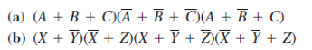

- Convert each of the following POS expressions to minimum SOP expressions using a Karnaugh map:
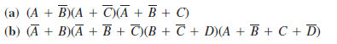

- Simplify the following Boolean function F together with the don't-care conditions d; then express the simplified function in minimum SOP and minimum POS.
(a) F(A, B, C, D) = Σ (0,6,8, 13, 14) ; d (A, B, C, D) = Σ (2, 4, 10)
(b) F(A, B, C, D) = Σ (I, 3, 5, 7, 9,15) ; d (A, B, C, D) = Σ (4, 6, 12, 13)

